**Project Summary: Market Analysis Report for National Clothing Chain**

1. **What is the correlation (R2 value) between sales and income?**

The correlation is 0.78.

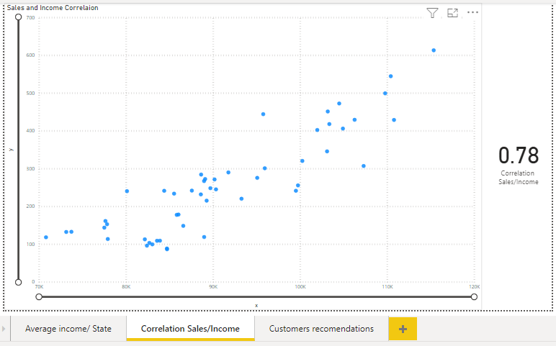

1. **What is the correlation (R2 value) between customer ratings and product return rate?**

The correlation is -0.83.

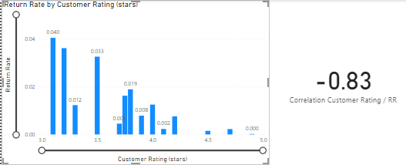

1. **What are the linear regression formulas to predict customer sales and customer incomes?**

Formulas:

Correlation Sales/Income =

VAR ct = VALUES('Regression Table'[y])

VAR cnt =

COUNTX(

KEEPFILTERS(ct),

CALCULATE(SUM('Regression Table'[x]) * SUM('Regression Table'[y]))

)

VAR sum_x =

SUMX(

KEEPFILTERS(ct),

CALCULATE(SUM('Regression Table'[x]))

)

VAR sum_y =

SUMX(

KEEPFILTERS(ct),

CALCULATE(SUM('Regression Table'[y]))

)

VAR sum_xy =

SUMX(

KEEPFILTERS(ct),

CALCULATE(SUM('Regression Table'[x]) * SUM('Regression Table'[y]) * 1.)

)

VAR sum_x2 =

SUMX(

KEEPFILTERS(ct),

CALCULATE(SUM('Regression Table'[x]) ^ 2)

)

VAR sum_y2 =

SUMX(

KEEPFILTERS(ct),

CALCULATE(SUM('Regression Table'[y]) ^ 2)

)

RETURN

DIVIDE(

cnt * sum_xy - sum_x * sum_y * 1.,

SQRT(

(cnt * sum_x2 - sum_x ^ 2)

* (cnt * sum_y2 - sum_y ^ 2)

)

)^2

1. **Which customer do you predict has the highest income?**

First name: Jon  
Last name: Little  
Predicted income: $ 558143.93

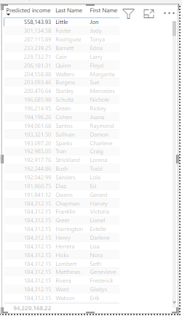

1. **Which product will be advertised the most?**

The product which has the best performance and will be advertised the most is the Sweater

